The Parish Church of St Andrew
Orford with Longford

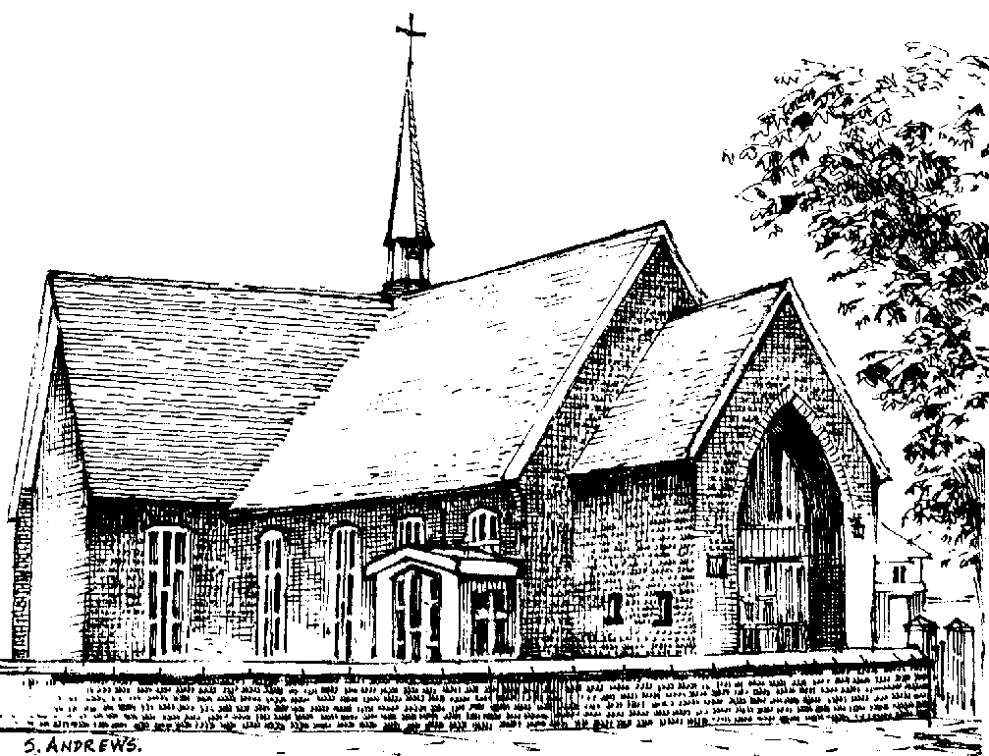

Thomas William (Tommy) Crozier
1934 - 2008

Friday 15th February 2008

Order of Service

ALL STAND as the funeral procession enters church. Once the family are seated, please SIT.

Introduction

Priest: We meet in the name of Jesus Christ, who died and was raised to the glory of God the Father. Grace and mercy be with you.
All: Amen.

The priest introduces the service

Priest: Let us pray: (please remain seated)

Almighty God, you judge us with infinite mercy and justice, and love everything you have made. In your mercy turn the darkness of death into the dawn of new life, and the sorrow of parting into the joy of heaven; through our Saviour, Jesus Christ. Amen

All: Merciful Father, hear our prayers and comfort us; renew our trust in your Son, whom you raised from the dead; strengthen our faith that all who have died in the love of Christ will share in his resurrection; who lives and reigns with you, in the unity of the Holy Spirit, one God, now and for ever. Amen

The Ministry of the Word

Hymn: “All things bright and beautiful” (please stand)

All things bright and beautiful,
all creatures great and small,
all things wise and wonderful,
the Lord God made them all.

Each little flower that opens,
each little bird that sings,
he made their glowing colours,
he made their tiny wings:

The purple headed mountain,
the river running by,
the sunset, and the morning
that brightens up the sky:

The cold wind in the winter,
the pleasant summer sun,
the ripe fruit in the garden,
he made them every one:

He gave us eyes to see them,
and lips that we might tell
how great is God almighty,
who has made all things well:

All things bright and beautiful,
all creatures great and small,
all things wise and wonderful,
the Lord God made them all.

The Scriptural Reading (1 Corinthians 15. 12-20)

The Address

Hymn: “There is a green hill” (please stand)

There is a green hill far away,
without a city wall,
where the dear Lord was crucified,
who died to save us all.

We may not know, we cannot tell,
what pains he had to bear,
but we believe it was for us
he hung and suffered there.
He died that we might be forgiven,
he died to make us good,
that we might go at last to heaven,
saved by his precious blood.

There was no other good enough
to pay the price of sin;
he only could unlock the gate
of heaven, and let us in.

O dearly, dearly has he loved,
and we must love him too,
and trust in his redeeming blood,
and try his work to do.

The Prayers:

Priest: God of mercy, Lord of life, you have made us in your image to reflect your truth and light: we give you thanks for Tommy, for the grace and mercy he received from you, for all that was good in his life, and especially for the memories we treasure today.

(after a short period of silence)

Lord, in your mercy
All: hear our prayer.

Priest: You promised eternal life to those who believe. Remember for good this your servant Tommy as we also remember him. Bring all who rest in Christ into the fullness of your kingdom where sins have been forgiven and death is no more.

Lord, in your mercy
All: hear our prayer.

Priest: Your mighty power brings joy out of grief and life out of death. Look in mercy on Tommy’s family and all who mourn at this time. Give them patient faith in times of darkness. Strengthen them with the knowledge of your love.

Lord, in your mercy
All: hear our prayer.

Priest: You are tender towards your children and your mercy is over all your works. Heal the memories of hurt and failure. Give us the wisdom and grace to use aright the time that is left to us here on earth, to turn to Christ and follow in his steps in the way that leads to everlasting life.

Lord, in your mercy
All: hear our prayer.

God of mercy, entrusting into your hands all that you have made and rejoicing in our communion with all your faithful people, we make our prayers through Jesus Christ our Saviour. Amen.

Priest: Let us pray with confidence as our Saviour has taught us

All: Our Father, who art in heaven, hallowed be thy name; thy kingdom come; thy will be done; on earth as it is in heaven. Give us this day our daily bread. And forgive us our trespasses, as we forgive those who trespass against us. And lead us not into temptation; but deliver us from evil. For thine is the kingdom, the power and the glory, for ever and ever. Amen.

Hymn: “How great thou art”

O Lord my God! When I in awesome wonder
Consider all the works Thy hand hath made,
I see the stars, I hear the mighty thunder,
Thy power throughout the universe displayed:

Then sings my soul, my Saviour God to Thee,
How great Thou art! How great Thou art!
Then sings my soul, my Saviour God to Thee,
How great Thou art! How great Thou art!

When through the woods and forest glades I wander
And hear the birds sing sweetly in the trees;
When I look down from lofty mountain grandeur,
And hear the brook, and feel the gentle breeze;

Then sings my soul ...

And when I think that God his Son not sparing,
Sent Him to die - I scarce can take it in;
That on the cross my burden gladly bearing,
He bled and died to take away my sin:

Then sings my soul ...

When Christ shall come with shout of acclamation
And take me home - what joy shall fill my heart!
Then shall I bow in humble adoration
And there proclaim my God, how great Thou art!

Then sings my soul ...

Commendation and Farewell [please remain standing]

Priest: Let us commend Tommy to the mercy of God our Maker and Redeemer.

The coffin is sprinkled with holy water taken from the font

Priest: With this water we call to mind Tommy’s baptism. As Christ went through the deep waters of death for us, so may he bring us to the fullness of resurrection life with Tommy and all the redeemed.

God our creator and redeemer, by your power Christ conquered death and entered into glory. Confident of his victory and claiming his promises, we entrust Tommy to your mercy in the name of Jesus our Lord, who died and is alive and reigns with you, now and for ever. Amen

All: Heavenly Father, in your Son Jesus Christ you have given us a true faith and a sure hope. Strengthen this faith and hope in us all our days, that we may live as those who believe in the communion of saints, the forgiveness of sins and the resurrection to eternal life; through Jesus Christ our Lord. Amen.

Priest: May God, in his infinite love and mercy, bring the whole Church, living and departed in the Lord Jesus, to a joyful resurrection, and the fulfilment of his eternal kingdom. Amen.

As the procession leaves church, the Nunc Dimittis is read. Please follow the family.

Acknowledgement: Common Worship: Pastoral Services, material from which is included in this service, is copyright © The Archbishops’ Council (2000)

